Department of Chemistry
NATIONAL INSTITUTE OF TECHNOLOGY, TIRUCHIRAPPALLI
COURSE OUTLINE TEMPLATE
Course Title |  |  | Computational methods in Chemistry
Course Code |  |  | CH616 |  |  |  | No. of Credits | 3 (Theory & Lab)
Department |  |  | Chemistry |  |  |  | Faculties | Prof. L.Cindrella  Dr. M. Sathiya
Programme |  |  | M.Sc.(Chemistry)
Course Coordinator  (if, applicable) |  |  | Dr. L. Cindrella (Theory & Lab)
E-mail |  |  | cind@nitt.edu  shakthikrish@gmail.com |  |  |  | Telephone No. | 9443765332 (Prof. CL)  9940060659 (Dr. MS)
Course Type |  |  | Elective course
COURSE OVERVIEW
This course is offered to II year M.Sc.(Chemistry) students. This 3 credit course is for theory and lab. Four classes (Theory and Lab) will be conducted per week.
COURSE OBJECTIVE
To introduce the theoretical and numerical protocols used in chemistry
COURSE OUTCOMES (CO)
Students would become familiar with the:
- C Programming and solving the equations in chemistry
- Numerical methods in chemistry
- Force field concepts
- Electronic structure calculations
COURSE TEACHING AND LEARNING ACTIVITIES
S.No. | Week |  |  | Topic |  |  |  |  |  | Mode of Delivery
1 | III week of January |  |  | Unit 1: Introduction to C: Basics concepts, C - Syntax: Character set - constants and variables, data types and sizes, declarations.  Unit 3: Introduction to numerical methods: Solving polynomial equations by Newton-Raphson method, Bisection method problems. |  |  |  |  |  | C&T, PPT
2 | IV week of January |  |  | Unit 1:  operators - expressions - conditional expressions, precedence and order of evaluation,  Unit 3:  Solutions of simultaneous equations - Gauss elimination, Jacobi iteration, matrix diagonalization, numerical differentiation and integration - Simpson’s rule, trapezoidal rule |  |  |  |  |  | C&T, PPT
3 | V week of January |  |  | Unit 1  statements and blocks, if-else, if-else-if and switch statements, while, for and Do – while loops.  Unit 3  determination of entropy, solution of differential equations - Runge-Kutta method - theory and application to thermodynamics, linear and non-linear curve fitting |  |  |  |  |  | C&T, PPT
4 | I week of February |  |  | Unit 1: break and continue statements, Go to and labels, basics of functions and types, header files. Unit 4: Force field methods - force field energy and parameterization |  |  |  |  |  | C&T, PPT
5 | II week of February |  |  | Unit 1: recursion, arrays – 1D and 2D, file handling concepts.  Unit 4: Electronic structure methods - SCF techniques, semi-empirical methods, basis sets and their classification |  |  |  |  |  | C&T, PPT
6 | III week of February |  |  | Unit 1:Tutorial and Practical session for unit 1  Unit 4:Density functional theory and methods |  |  |  |  |  | C&T, PPT
7 | IV week of February |  |  | Unit 2: Kinetics - solving rate equations, thermodynamics - heats of reactions, heat capacity, entropy  Unit 4: Introduction to molecular modeling methods, Coordinates conversion for simple molecules. |  |  |  |  |  | C&T, PPT
8 | I week of March |  |  | Unit 2: spectroscopy - moment of inertia, wave numbers of stokes and anti-stokes Raman lines, masses of isotopes from rotational and vibrational spectroscopic data  Unit 5: Geometry convergence, energy convergence, dipole moment convergence, |  |  |  |  |  | C&T, PPT
9 | II week of March |  |  | Unit 2: Group theory - Huckel MO calculations of delocalisation energy, hybridisation schemes and symmetries of vibrations in non - linear molecules  Unit 5: vibrational frequencies convergence |  |  |  |  |  | C&T, PPT
10 | III week of March |  |  | Unit 2: Crystallography - d spacings for an orthorhombic crystal  Unit 5: Bond dissociation curve, angle bending curve, transition state modeling using Chemoffice and Gaussian software - demo on docking software. |  |  |  |  |  | C&T, PPT
11 | IV week of March |  |  | Unit 2 Fourier synthesis of electron density using structure factor, axial angles of a triclinic crystal.  Unit 3, 4: Tutorial and Practical. |  |  |  |  |  | C&T, PPT
12 | I week of April |  |  | Unit 2: Tutorial and Practical session  Unit 4: Tutorial and Practical session |  |  |  |  |  | C&T, PPT
13 | II week of April |  |  | Unit 2: Tutorial and practical session  Unit 5: Tutorial and Practical session |  |  |  |  |  | C&T, PPT
COURSE ASSESSMENT METHODS
S.No. |  | Mode of Assessment |  |  | Week/Date | Duration |  |  | % Weightage
Theory
1 |  | Assignment/Quiz/ Tutorials |  |  | II week of Feb | One week |  |  | 10
2 |  | Test I |  |  | IV week of Feb | 60 minutes |  |  | 15
3 |  | Assignment /Quiz/ Tutorials |  |  | II week of March | One week |  |  | 10
4 |  | Test II |  |  | IV week of March | 60 minutes |  |  | 15
5 |  | Final Asessment |  |  | IV week of April | 3 hours |  |  | 50
Theory = Total (100)
ESSENTIAL READINGS : Textbooks, reference books Website addresses, journals, etc
- K. V. Raman, Computers in Chemistry, Tata McGraw Hill, 1993.
- F. Jensen, Introduction to Computational Chemistry, John Wiley & Sons, 2003.
- C. Balagurusamy, Programing in C, Tata McGraw Hill, 1997.
- M. K. Jain, Numerical Methods for Scientific and Engineering Computation, Wiley Eastern Ltd, 1995.
- User manuals of Gaussian09, Chemoffice Ultra and Gauss View.
COURSE EXIT SURVEY (mention the ways in which the feedback about the course is assessed and indicate the attainment also)
1. Feedback from students during class committee meetings.
2. Anonymous feedback through questionnaire at the end of the semester.
COURSE POLICY (including plagiarism, academic honesty, attendance, etc.)
- 80% attendance is compulsory for appearing final assessment.
- Plagiarism is strictly not allowed.
- For those students who missed Test I and Test II due to genuine reasons, retest will be
conducted during the III week of April 2018.
- Extra classes will be conducted, if attendance is shortage for students.
ADDITIONAL COURSE INFORMATION
The faculty will be available for consultation at times as per the intimation by the faculty.
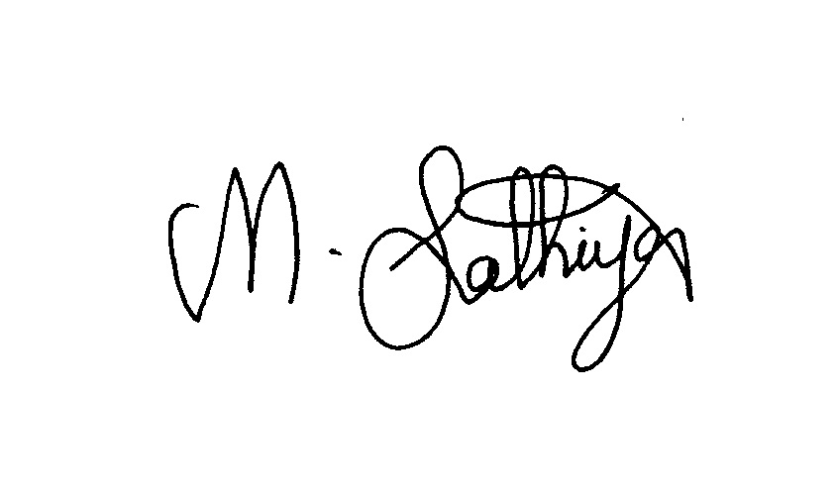
Coordinator __________ CC-Chairperson ________________ HOD ____________

